Birthday Blessings!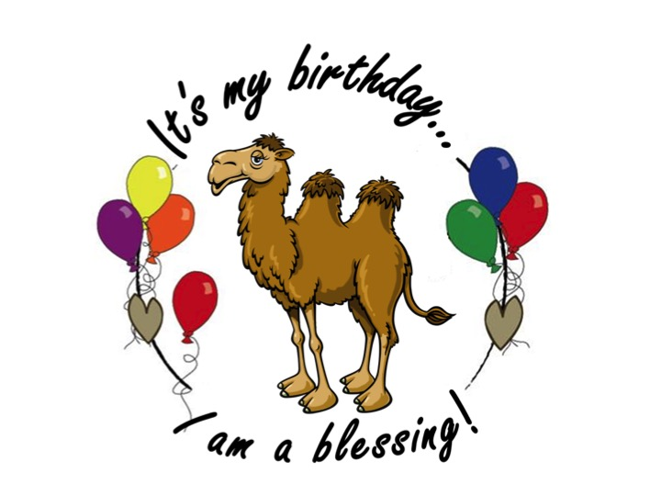

Use blessings to celebrate birthdays! Invite the child with the Birthday to come forward.
Say: How old will you be on your birthday?
(Let the child tell you and then turn to the other children and …)
Say: (Name of child) is (age)! What is she/he?
All the children shout: She/he is a blessing!!!

And then you put a big, “It’s my Birthday, I am a blessing” sticker on them.

You can use these at Sunday School, After School programs, at home with your own kids, at daycare and weekday preschools.

