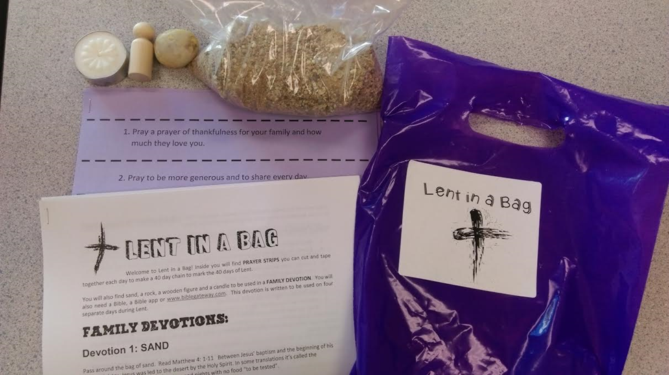
Lent In a Bag

Welcome to Lent in a Bag! Inside you will find prayer strips you can cut and tape together each day to make a 40 day chain to mark the 40 days of Lent.

You will also find sand, a rock, a wooden figure and a candle to be used in a family devotion. You will also need a Bible, a Bible app or www.biblegateway.com. This devotion is written to be used on four separate days during Lent.

Family Devotions:
Devotion 1: SAND
Pass around the bag of sand. Read Matthew 4: 1-11 Between Jesus’ baptism and the beginning of his adult ministry, Jesus was led to the desert by the Holy Spirit. In some translations it’s called the wilderness. Jesus was there for 40 days and nights with no food “to be tested”.
Accept all answers when you ask the following “I wonder” questions:
- I wonder … what is a desert like?
- I wonder … do you think Jesus was hungry after 40 days in the desert with no food?
- I wonder … why would Jesus want to go to the desert?
- I wonder … what kind of things do you think Jesus thought about all by himself in the desert?
Even though God hears our prayers anytime, anywhere we are, it is usually easier for us to focus on God when it is quiet and still.
Where do you go for peace and quiet? What have you learned there? What might you learn there?
Close with a prayer thanking God for loving us and asking for help that we be still and focus on God’s goodness and love and how we can reflect that to the world.

Devotion 2: ROCK
Pass around the rock. Read Matthew 4: 1-11 While in the wilderness, Jesus was invited to transform stone into bread. Though he resisted the temptation there and then, he became well known for feeding people who were hungry for food, such as the Feeding of the 5000 Read John 6:1-13.
Jesus not only fed people food for their bodies, Jesus also “fed” people by words of encouragement and by simple acceptance when other people looked down on them.
Accept all answers when you ask the following questions:

- What does the rock feel like? (hard, cold)
- Sometimes people say that someone has a cold, hard heart. What do you think they mean by that?
- I wonder …how would people with a heart like that treat others?
- I wonder …How would they treat God?
- What do you think is the opposite of a hard, cold heart?
- Which one do you think God wants us to have? Why?
- Which kind of heart do you think Jesus has?
- How can we show others that our hearts are loving and accepting?
- What can you do this week to demonstrate your heart to others?
Have each family member make a commitment to do at least one thing this upcoming week to demonstrate their heart. Throughout the upcoming week discuss at dinnertime to see how everyone’s heart is doing.

Close with a prayer thanking God for His Son Jesus and ask for help that we can have a heart like Jesus’ so others will be able to know through us what Jesus’ heart is like.

Devotion 3: Human Figure
Pass around the wooden figure.

Ask the children to tell you the story of Jesus’ birth – the Christmas story. Ask who Jesus’ mother was. God chose Mary, a human to be the mother of His Son. God sent His very own Son here on earth to live as a human and to live among humans so that Jesus would understand what it is like to be human. Jesus knows what we are like and Jesus loves us.
- What does the word “capable” mean? (able to do something; having the qualities or abilities that are needed to do something-Merriam Webster)
Jesus knows from experience that we humans are capable of being tempted to do things that are not pleasing to God, but we are also each capable of great things – Godly things, things that would please God.
- What are some things you can do that can please God?
- What can you do each day of Lent to please God?

Pick one thing you will do each day of Lent to reflect God’s goodness and love to others. By reflecting God’s goodness and love to others, not only do we become closer to God, we are helping others see God and become closer themselves.

Close with a prayer that others may see God’s love through your words and actions. Discuss your progress this week with your family.

Devotion 4: Candle
Pass around the unlit candle. Explain that Lent begins with Ash Wednesday in the dimness of late winter and ends with the burst of bright spring in Easter. Jesus is, according to John’s gospel the Light of the World.
Light the candle. Read Matthew 5:14-16. Jesus tells his disciples that THEY are the light of the world.
- Why is light important?
- Is it hard to find your way and know where to go or what to do without light?
- What happens when you hide the light under a basket?
- What do you think Jesus meant when he said that WE as Jesus’ followers are the Light of the World?
- How should we live our lives if WE are God’s light in the world?
- Do we sometimes hide our light under a basket?
- Candles need air to stay lit. What do we need to keep our “light” lit?
Think of a way we can shine our light for others so that they may see Jesus through us and practice that this week.
Close with a prayer thanking God for His Son Jesus. Pray that we may shine our light of God’s goodness and mercy to all we meet, so that the world will be filled with God’s love, hope and peace.
What is Ash Wednesday?
Ash Wednesday, February 10 this year, marks the beginning of the season of Lent, and ends with the greatest event in history, the day we celebrate the Resurrection of our Lord Jesus--Easter Sunday!
On Ash Wednesday ashes are placed on the foreheads in the sign of the cross to remind them of Christ's death, of the sorrow one should feel for his or her sins, and of the necessity of repenting, which is turning from sin – anything that separates us from God- and turning to God. The ashes on our foreheads remind us that we are children of God and disciples of Christ. Traditionally, the ashes are obtained from burned palm branches from the Palm Sunday of the previous year. Argyle UMC’s Ash Wednesday service is at 6:30 pm February 10. Children are welcome.
What is Lent?
Lent means "lengthening" as in the lengthening of days in springtime It is the 40-day period leading up to Easter, not counting Sundays, because they are considered “mini-Easters” or Resurrection Sundays. It is a time for Spiritual renewal, refreshing.
Why are there 40 days of Lent?
In the 40 days of Lent believers unite themselves to Jesus in the desert, Matthew 3:16-4:11.
"For we have not a high priest who is unable to sympathize with our weaknesses, but one who in every respect has been tested as we are, yet without sinning." Hebrews 4:15.
What do we do during those 40 days?
Lent is a special time of reflecting in prayer and fasting upon the importance of our redemption and salvation made possible through Christ's suffering on the cross and his resurrection from the dead. Many people give up something they enjoy doing or eating during Lent as a constant reminder of how Jesus gave up his life for theirs, or they may add something such as writing in a journal or collecting money for missions. AUMC will have special Lenten offerings each week for missions and children are encouraged to participate.

We pray that this season of Lent will be a time for you and your family to grow even closer to God as we reflect together on the incredible love God has for us all.

Many blessings,
Liz Diebold
Argyle United Methodist Church Children’s Ministry
liz@argyleumc.org

