Whole Body Love Flow
Pose | Say | Visual | Verbal Cues (for first time through)
Sukhasana/Easy Pose | We’ll move through poses as we remember God’s greatest commandment and say the scripture out loud. | 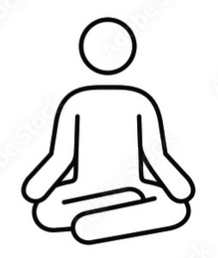 | Sit in a comfortable position on the floor with your legs crossed. Sit straight, hands on your knees. Close your eyes and breathe.
Camel pose (Heart) | And you shall love the Lord your God with all your heart, | 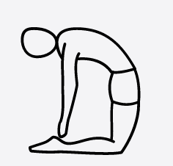 | Sit on your knees. Rise up onto your knees reaching your head toward the sky. Palms rest on your lower back fingers facing toward the floor. Stretch your head up and arch back toward your feet opening your chest/heart to the sky. You can let your hands fall toward your feet if you want.
Bound angle/ankle pose w/head toward ground (Soul) | And with all your soul, | 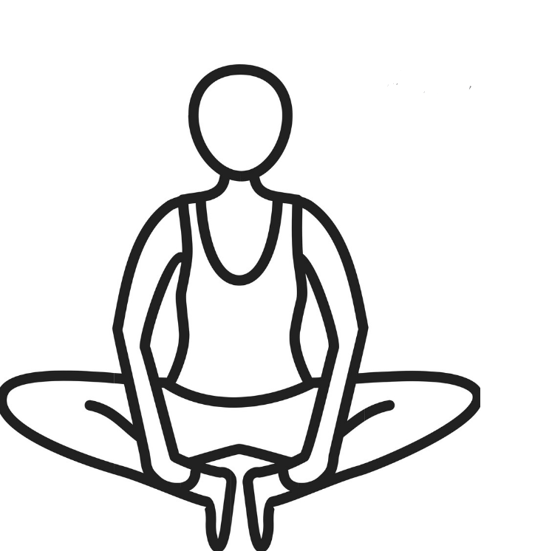 | Return to a seated position and bring the soles of your feet together. Place your hands on your ankles. Stretch your head toward the sky and reach your head toward your ankles as far as is comfortable.
Low Crescent Lunge (Mind) | And with all your mind, | 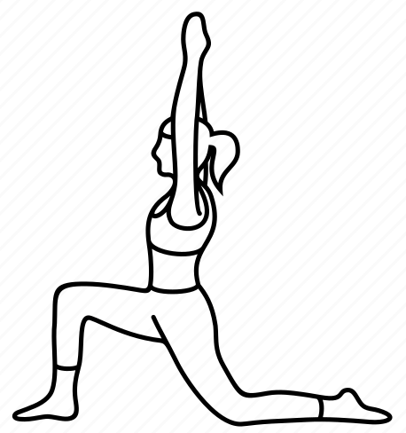 | Come onto your hands and knees. Bring your right foot in front of you and place it flat on the floor in a lunge. As your move your torso up and forward, raise your hands up over your head. Back knee stays on the ground.
Plank pose (Strength) | And with all your strength. | 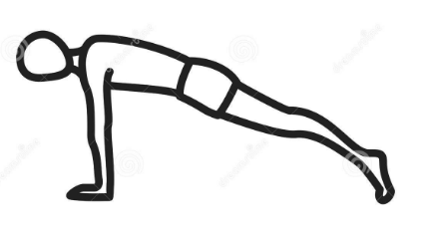 | Lower your hands and return to hands and knees. Push into your feet as you raise your knees off the ground making a flat table Hold and breathe.
Child’s Pose (Love Neighbor As Self) | The second is this: You shall love your neighbor as yourself. Now we’ll take three deep breaths and repeat 2 more times. | 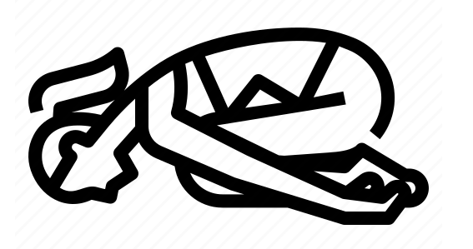 | Bring your knees down to the floor. Push your hips back to sit on your ankles. Bend your torso forward until your forehead touches the ground. Stretch your arms back to rest near your feet.

